AP LANG
IDENTIFYING STYLE

Directions: Read both the speeches below by Emma Gonzales, A Marjory Stoneman Douglass High School student shooting survivor and identify and analyze the rhetorical devices she uses to create the tone and develop her message.

I. Transcript Of Emma Gonzalez's March For Our Lives Speech Will Absolutely Crush You
By CHRIS TOGNOTTI (Bustle) March 24 2018
https://www.bustle.com/p/transcript-of-emma-gonzalezs-march-for-our-lives-speech-will-absolutely-crush-you-8596656

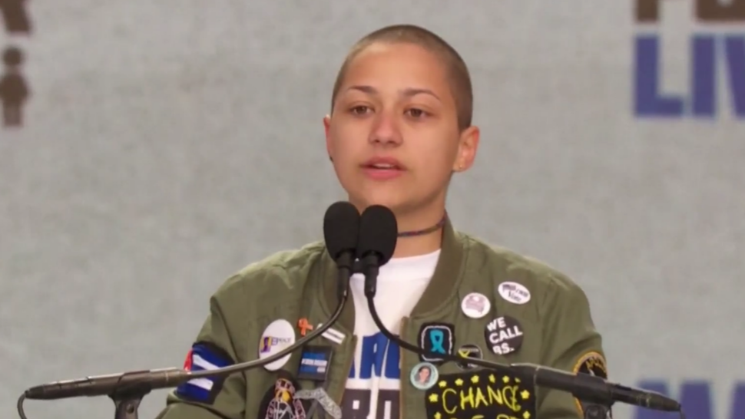
NBC News/YouTube
On Saturday, March 24, hundreds of thousands of demonstrators turned out for the March For Our Lives, a massive public protest in support of gun control. And those who did bore witness to a deeply emotional and powerful speech by Emma González, a survivor of the Stoneman Douglas High School shooting. Perhaps the strongest and most evocative part of her speech, however, came not through her words, but through her silence.
Halting her speech after naming and describing the people slain in the shooting, González fell silent for six minutes and 20 seconds, the same amount of time it took for the gunman's assault to come to an end. During the protracted silence, the assembled crowd joined her in silence, occasionally shouting words of support and chanting "never again!"
--------------------------------------------------------------------------------------------------------------------
Six minutes, and about 20 seconds. In a little over six minutes, 17 of our friends were taken from us, 15 more were injured, and everyone, absolutely everyone in the Douglas community was forever altered. Everyone who was there understands. Everyone who has been touched by the cold grip of gun violence understands. For us, long, tearful, chaotic hours in the scorching afternoon sun were spent not knowing.

Twitter Ads info and privacy
No one understood the extent of what had happened. No one could believe that there wer bodies in that building waiting to be identified for over a day. No one knew that the people who were missing had stopped breathing long before any of us had even known that a code red had been called. No one could comprehend the devastating aftermath, or how far this would reach, or where this would go.

For those who still can't comprehend, because they refuse to, I'll tell you where it went. Six feet into the ground, six feet deep. Six minutes and 20 seconds with an AR-15, and my friend Carmen would never complain to me about piano practice. Aaron Feis would never call Kyra "miss sunshine," Alex Schachter would never walk into school with his brother Ryan, Scott Beigel would never joke around with Cameron at camp, Helena Ramsay would never hang around after school with Max, Gina Montalto would never wave to her friend Liam at lunch, Joaquin Oliver would never play basketball with Sam or Dylan. Alaina Petty would never, Cara Loughren would never, Chris Hixon would never, Luke Hoyer would never, Martin Duque Anguiano would never, Peter Wang would never, Alyssa Alhadeff would never, Jamie Guttenberg would never, Jamie Pollack would never.
It was then that Gonzalez fell silent, only speaking once more after a time beeped, telling her it had been six minutes and 20 seconds since she'd taken the stage. The silence was extremely evocative, and isn't done justice by the transcript

Once the time had elapsed, Gonzalez explained why she'd fallen silent, and implored the marchers to fight for their lives.
"Since the time that I came out here, it has been six minutes and 20 seconds," she said. "The shooter has ceased shooting, and will soon abandon his rifle, blend in with the students as they escape, and walk free for an hour before arrest. Fight for your lives before it's someone else's job."
Gonzalez was the last speaker at the rally, and she definitely left a mark, with TV cameras showing some people in tears as they listened to her words. It remains to be seen how much impact the March For Our Lives might have on the American political process, but as far as its participants are concerned, it's clearly been a very powerful and heartfelt experience.

II. Florida student Emma Gonzalez to lawmakers and gun advocates: 'We call BS'
(CNN) Emma Gonzalez, a senior at Marjory Stoneman Douglas High School, addressed a gun control rally on Saturday in Fort Lauderdale, Florida, days after a gunman entered her school in nearby Parkland and killed 17 people.
Below is a full transcript of her speech:

We haven't already had a moment of silence in the House of Representatives, so I would like to have another one. Thank you.

Every single person up here today, all these people should be home grieving. But instead we are up here standing together because if all our government and President can do is send thoughts and prayers, then it's time for victims to be the change that we need to see. Since the time of the Founding Fathers and since they added the Second Amendment to the Constitution, our guns have developed at a rate that leaves me dizzy. The guns have changed but our laws have not.

We certainly do not understand why it should be harder to make plans with friends on weekends than to buy an automatic or semi-automatic weapon. In Florida, to buy a gun you do not need a permit, you do not need a gun license, and once you buy it you do not need to register it. You do not need a permit to carry a concealed rifle or shotgun. You can buy as many guns as you want at one time.

I read something very powerful to me today. It was from the point of view of a teacher. And I quote: When adults tell me I have the right to own a gun, all I can hear is my right to own a gun outweighs your student's right to live. All I hear is mine, mine, mine, mine.

Instead of worrying about our AP Gov chapter 16 test, we have to be studying our notes to make sure that our arguments based on politics and political history are watertight. The students at this school have been having debates on guns for what feels like our entire lives. AP Gov had about three debates this year. Some discussions on the subject even occurred during the shooting while students were hiding in the closets. The people involved right now, those who were there, those posting, those tweeting, those doing interviews and talking to people, are being listened to for what feels like the very first time on this topic that has come up over 1,000 times in the past four years alone.

I found out today there's a website shootingtracker.com. Nothing in the title suggests that it is exclusively tracking the USA's shootings and yet does it need to address that?
Because Australia had one mass shooting in 1999 in Port Arthur (and after the) massacre introduced gun safety, and it hasn't had one since. Japan has never had a mass shooting. Canada has had three and the UK had one and they both introduced gun control and yet here we are, with websites dedicated to reporting these tragedies so that they can be formulated into statistics for your convenience.

I watched an interview this morning and noticed that one of the questions was, do you think your children will have to go through other school shooter drills? And our response is that our neighbors will not have to go through other school shooter drills. When we've had our say with the government -- and maybe the adults have gotten used to saying 'it is what it is,' but if us students have learned anything, it's that if you don't study, you will fail. And in this case if you actively do nothing, people continually end up dead, so it's time to start doing something.

We are going to be the kids you read about in textbooks. Not because we're going to be another statistic about mass shooting in America, but because, just as David said, we are going to be the last mass shooting. Just like Tinker v. Des Moines, we are going to change the law. That's going to be Marjory Stoneman Douglas in that textbook and it's going to be due to the tireless effort of the school board, the faculty members, the family members and most of all the students. The students who are dead, the students still in the hospital, the student now suffering PTSD, the students who had panic attacks during the vigil because the helicopters would not leave us alone, hovering over the school for 24 hours a day.
There is one tweet I would like to call attention to. So many signs that the Florida shooter was mentally disturbed, even expelled for bad and erratic behavior. Neighbors and classmates knew he was a big problem. Must always report such instances to authorities again and again. We did, time and time again. Since he was in middle school, it was no surprise to anyone who knew him to hear that he was the shooter. Those talking about how we should have not ostracized him, you didn't know this kid. OK, we did. We know that they are claiming mental health issues, and I am not a psychologist, but we need to pay attention to the fact that this was not just a mental health issue. He would not have harmed that many students with a knife.

And how about we stop blaming the victims for something that was the student's fault, the fault of the people who let him buy the guns in the first place, those at the gun shows, the people who encouraged him to buy accessories for his guns to make them fully automatic, the people who didn't take them away from him when they knew he expressed homicidal tendencies, and I am not talking about the FBI. I'm talking about the people he lived with. I'm talking about the neighbors who saw him outside holding guns.

If the President wants to come up to me and tell me to my face that it was a terrible tragedy and how it should never have happened and maintain telling us how nothing is going to be done about it, I'm going to happily ask him how much money he received from the National Rifle Association.

You want to know something? It doesn't matter, because I already know. Thirty million dollars. And divided by the number of gunshot victims in the United States in the one and one-half months in 2018 alone, that comes out to being $5,800. Is that how much these people are worth to you, Trump? If you don't do anything to prevent this from continuing to occur, that number of gunshot victims will go up and the number that they are worth will go down. And we will be worthless to you.

To every politician who is taking donations from the NRA, shame on you.

Crowd chants, shame on you.

If your money was as threatened as us, would your first thought be, how is this going to reflect on my campaign? Which should I choose? Or would you choose us, and if you answered us, will you act like it for once? You know what would be a good way to act like it? I have an example of how to not act like it. In February of 2017, one year ago, President Trump repealed an Obama-era regulation that would have made it easier to block the sale of firearms to people with certain mental illnesses.

From the interactions that I had with the shooter before the shooting and from the information that I currently know about him, I don't really know if he was mentally ill. I wrote this before I heard what Delaney said. Delaney said he was diagnosed. I don't need a psychologist and I don't need to be a psychologist to know that repealing that regulation was a really dumb idea.

Republican Senator Chuck Grassley of Iowa was the sole sponsor on this bill that stops the FBI from performing background checks on people adjudicated to be mentally ill and now he's stating for the record, 'Well, it's a shame the FBI isn't doing background checks on these mentally ill people.' Well, duh. You took that opportunity away last year.

The people in the government who were voted into power are lying to us. And us kids seem to be the only ones who notice and our parents to call BS. Companies trying to make caricatures of the teenagers these days, saying that all we are self-involved and trend-obsessed and they hush us into submission when our message doesn't reach the ears of the nation, we are prepared to call BS. Politicians who sit in their gilded House and Senate seats funded by the NRA telling us nothing could have been done to prevent this, we call BS. They say tougher guns laws do not decrease gun violence. We call BS. They say a good guy with a gun stops a bad guy with a gun. We call BS. They say guns are just tools like knives and are as dangerous as cars. We call BS. They say no laws could have prevented the hundreds of senseless tragedies that have occurred. We call BS. That us kids don't know what we're talking about, that we're too young to understand how the government works. We call BS.

If you agree, register to vote. Contact your local congresspeople. Give them a piece of your mind.

(Crowd chants) Throw them out.

