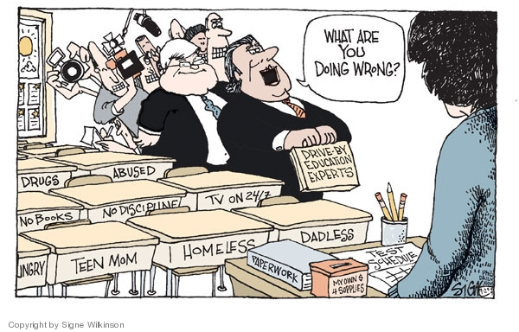
VISUAL
RHETORIC:
Things to consider when analyzing a political cartoon
Cartoonist’s Bio: Signe Wilkinson is an editorial cartoonist best known for her work at the Philadelphia Daily News. Wilkinson is the first female cartoonist to win the Pulitzer Prize for Editorial Cartooning (1992). She started her career as a reporter and began drawing the people she was reporting on. She realized cartooning combined her interests in art and politics. (Source: Washington Post)

- First, describe what you see: What is happening in this cartoon? What people and objects are shown? What words are used? What do you see that looks different than what you would see in a photograph?
- What was happening when this cartoon was made? (locally, nationally, internationally?)
- Who do you think might be the intended audience for this cartoon?
- Think about the point the cartoonist was trying to make with this cartoon. How were you persuaded? What visual strategies were used to persuade the audience? (Exaggeration? Irony? Symbolism? Analogy? Labeling? Refer to list of definitions on the back.)
- How would the cartoon be different if it was created by a cartoonist with a different point of view?

What does this cartoon make you wonder about? (Who, what, when, where, why?)
Record one follow-up question here: What might happen when the teachers are overwhelmed? In the image, the
teacher has a “fund” box for buying her own classroom supplies. At what point will this environment and the
lack of support and understanding from politicians be too much to make what could be a creative and rewarding job
no longer worth it?
When in doubt, refer to the SOAPSTone acronym when analyzing non-fiction. Below is a
completed SOAPSTone for Wilkinson’s cartoon.
Subject: | Education experts who are not educators, but often place blame on teachers for issues that effect learning that are often out of their control.
Occasion: | Educational “experts” are stopping by to interrogate a teacher in her classroom.  Reporters are following them in the door to capture the “news.”
Audience: | Possibly educational “experts” like politicians (the white-haired one in the image looks like Newt Gingrich, Speaker of the House of Representatives from 1995-1999), but also anyone who is not an educator and claims to know what is best, and likes to assign blame, but isn’t in the room long enough to understand the complexity of the challenges educators and students face on a daily basis in and  out of the home.
Purpose: | To confront the so called “experts” who have the audacity to blame teachers without understanding  the issues (issues are listed on chairs like a seating chart: homelessness, teen moms, hungry, etc.).
Speaker: | Possibly teachers? Frustrated educators who DO understand the real issues, feel that their jobs have been reduced to prepping students for standardized testing and filling out paperwork, and see the real issues the kids face,
Tone: | Accusatory: The “experts” appear to be charging in and accusing the teacher of professionally doing something  “wrong” while taking credit for addressing the problem in front of the press.

Please use the SOAPSTone acronym to analyze your political cartoon. If you cannot easily locate the source of the cartoon
(the newspaper, date originally published, etc.), please research the cartoonist and record one thing you learn about her/him.

