A journey south bonds an unlikely pair in ‘Green Book’

By Kristen Page-Kirby, November 20, 2018, The Washington Post
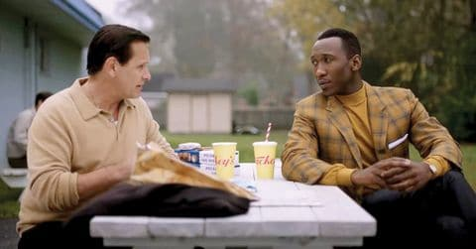
A trip though the South is no picnic for Tony (Viggo Mortensen) and Don (Mahershala Ali). Universal Pictures

Directions: Read the article below about Green Book and annotate in the right-hand margin.
Consider: Identity of the characters and setting as you make notes.

Early in “Green Book,” Tony Vallelonga, played by Viggo Mortensen, arrives at his Bronx home and finds some black handymen fixing his sink. After they leave, he delicately uses two fingers to pick up the water glasses they drank out of and deposits them in the garbage can.
So it’s hard to believe that Tony would agree to drive a black musician around the Deep South in 1962. Except “Green Book,” which opens nationally Wednesday, is based on a true story.
Tony, better known as “Tony Lip,” is working as a bouncer at the Copacabana when he’s hired by pianist Dr. Don Shirley (“Moonlight’s” Mahershala Ali) to be his driver and bodyguard as the musician — “Doc,” to Tony — embarks on a series of gigs playing at places where he’s not allowed to eat.
The dramedy’s title refers to a travel guide for African-Americans, published annually from the 1930s into the 1960s, originally called “The Negro Motorist Green-Book.” It listed safe restaurants and hotels in the South, as well as the names of towns to avoid — including “sundown towns,” where it was illegal for black people to be after sunset.
As the two set out, neither has any idea what they’re in for.
“Doc, he’s ignorant about people like Tony and how they live and how they think,” says Mortensen (“Captain Fantastic”). “When he first meets Tony, he’s like, ‘This guy is just a pig. This is going to be a really long trip.’ Then Tony’s thinking, ‘Why is this guy stuck-up? This is going to be a really long trip.’ ”
As Tony and Don make their really long trip, the two begin to find more of an understanding — while still finding time to annoy each other.
Director Peter Farrelly — who co-wrote the script with Nick Vallelonga, the real-life Tony’s son, and Brian Currie — wanted the film to examine the impact of the journey on both participants.
“There’s the white savior trope and the black savior trope,” Farrelly says. “We didn’t want either of those; it’s just done too much in Hollywood films, and that wasn’t the story. It would have been inaccurate. The truth is these guys both changed on that journey. They changed each other.”
And their contact with the racism of that time and place winds up forging a team.
“Without even realizing it, it’s pushing them closer,” Mortensen says. “It’s like they’re back to back, and their backs gradually touch. It’s not me versus you anymore. It’s us against all these guys.”

Quickwrite: Describe a time when you or someone in your family spent time with someone in a new place or taken a trip with someone and become closer or learned to understand each other better because of the journey. (Interview a family member if you do not have an experience you can share.)

Score: ______/10

