How to ANNOTATE
Tips for improving your annotation skills and more importantly,
activating your higher level thinking skills to get MORE out of literature…
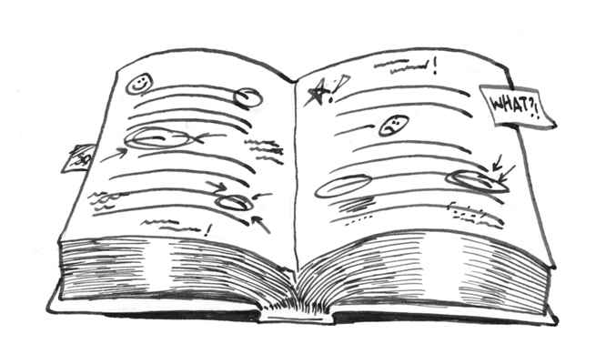
Annotation Expectations: By second semester in Pre-IB English 9, students are expected to make more insightful comments, demonstrating their ability to analyze an author’s intentional use of devices, language, and syntax to create meaning. By second semester, students should be making fewer personal connections and moving toward more textual connections (within the work itself), text-to-text connections, and connections beyond literature (cultural, or political, or historical) when applicable. Check out the back of this handout for student annotations that ROCK!
Directions: Carefully review the sample student comments and the teacher responses for each below. The next time you are asked to read a text, keep these tips in mind. Consider the expectations outlined above, and challenge yourself to engage on a higher level with the text. It just takes practice. Sometimes you may not be able to write ALL of your thoughts down as you read, but challenging yourself to dig deeper, doing the critical thinking, is important!
 | STUDENT ANNOTATIONS: | TEACHER FEEDBACK AND TIPS:
1. | I can relate to that. Or, “That has happened to me.” | What in particular can you relate to? Is your connection something that might be a universal theme in the text? If there is a message, theme, feeling or tone established by the author, discuss it.  (Tip: At this point, let’s move on from recording this type of response, unless you are given a writing prompt that asks you to make personal connections with the text. The bigger questions in this course: Why do writers make the choices they make and for what effect?)
2. | LOL | Are you texting with the author? If something is intentionally humorous, discuss the specific literary device or plot point that made you laugh and address the author’s intention.  (Tip: Avoid text-speak unless you are simply short on time.)
3. | Simile | Instead of stopping at identifying the use of a simile, metaphor, or personification, etc., dig deeper: What purpose does the use of this device serve? How does the device make a meaningful difference in the story--help the reader understand the character, visualize a key event, experience, etc.?  (Tip: Identify devices, but attempt to determine the author’s intent in using the device whenever possible.)
4. | Time period is important. | Yes, it is! Can you make an inference about how it might be important to the setting.  (Tip: When given a clue about the setting, try to make a few notes if possible about the setting if you can. What does the time of day, weather, time period, etc. possibly provide as far as context in the text?)
5. | Not sure what this word means. [word from text is underlined] | Again, this is step one: Identifying what you don’t know. Step two is fixing that.  (Tip: If you have a phone with you, or any access to the internet, or even a dictionary, look the word up and record the definition so you can add the word to YOUR lexicon. Be pro-active. Broaden your command of language.)
6. | That is messed up. [Referring to a character’s treatment of another character] | Great! You are emotionally bothered by an action of a character. The author would feel some success! That is step one: Identifying a character’s actions. But the important step comes next: Dig deeper.  (Tip: When a character’s actions surprise or offend or impress, you in some way, consider WHY the author has the character act that way. What do you believe is the author’s intent? What do the actions, etc. tell the reader about this character, what might the actions foreshadow? Is the character dynamic? Static?)
7. | This is a conflict. | Awesome! You are identifying plot points! What kind of a conflict is it? (Man v. Self? v. Man?, v. Nature? Is the conflict internal, external, or both?)  (Tip: When you suspect a conflict in the plot: 1) try to identify the specific type, and 2) begin looking for how the author develops the conflict. You might even be able to start to make predictions about how the conflict might reach a climax and how it might be resolved!)
The Scarlet Ibis
By: James Hurst
Thoughtful Annotations by English 9 Students*
1. Simile—creates imagery to establish setting
(contrasting poetic exposition with initial accident?)
2. Detailed descriptions—build up the character’s traits
3. [Author] Begins to show the protagonist’s somewhat
selfish motives
4. Mood: regret!
5. New setting—wonder if events will change or influence actions of characters?
6. Rising action—building the main conflict
7. Bird=symbol of freedom
8. I predict he will walk based on actions
9. Scene develops character’s dedication
10. Simile—describes how the loss feels and shows that our greatest enemies are sometimes ourselves
11. [At end of story] Themes : Spend time with those you love; power of pride and shame
12. Scarlet Ibis and Doodle: Strong parallel imagery (neck, legs, and color red are all similarities)
13. Story’s climax
14. Word choice: reveals maturity of the narrator
15. Slang—makes characters more genuine, credible
16. [Referencing the wind dying toward the end of the story] Author uses personification to create foreshadowing—I know something terrible will occur
17. Resolution—the narrator’s shame leads to tragedy

Wow! One student broke the text into sections or “chapters”, and named each one, summarizing in a few words the purpose of each: 1) The Death, Then Life, of Doodle, 2) My Brother’s Go-Cart, 3) Baby Steps, 4) Doodle’s Development Program, 5) The Fallen Ibis.

*Special thanks to Joey, Sage, and Richie for allowing us all to learn from their annotations.

