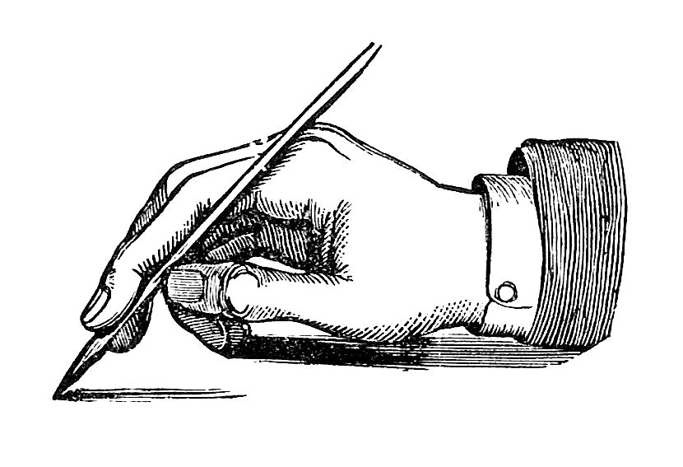
Writer’s Notebook (Journal)
Expectations and Guidelines

“Fill your paper with the breathings of your heart.”
--William wordsworth
- Have your journal on your desk when class begins every Monday. We will write after mindfulness.
- As soon as we finish meditating, start journaling. This is a silent time. Please do not talk.
- Don’t erase anything you write. You may place a line through it.
- You may write about anything you want. Nothing is off limits. Include bad words if you choose. You are not censored in your journal.
- No one will read your journal. It is private. To learn to live as a writer, you need a place to record hopes, dreams, problems, fears, plans, writing ideas, etc. without the worry that someone is going to judge or score what you write.
- The entire time we are writing (usually 15 minutes), keep your pen moving. If you can’t think of anything to write about, write, “I can’t think of anything to write about.” Write this over and over. Your brain will relax a bit and you will think of something—trust yourself! You can even tell your journal why you are stuck.
- Date every entry at the top of the page. You will reflect on your entries. It is helpful to know when you wrote what you wrote as you reflect. You will be amazed over time by your growth!
- Try to write at least a page every day. (You will earn a homework grade once per quarter for this.) But, if you accomplish this, don’t stop. Keep writing.
- While no one plans to read your notebook without your permission, if, on accident, your teacher sees something you’ve written that concerns her, it is her legal responsibility to report it.
- Your notebook will be kept in a safe place in class to honor your privacy. Journals do not go home to protect your privacy and so they do not get lost.

Please tape these guidelines in your journal. Have fun writing and enjoy the freedom from prompts! Write for YOU!

--Ms. Mauer

“The good writer seems to be writing about himself,
but has his eye always on that thread of the Universe
which runs through himself and all things.”
--Ralph Waldo Emerson

