From: The Absolutely True Diary of a Part-Time Indian
By: Sherman Alexie
English 9A, Q1

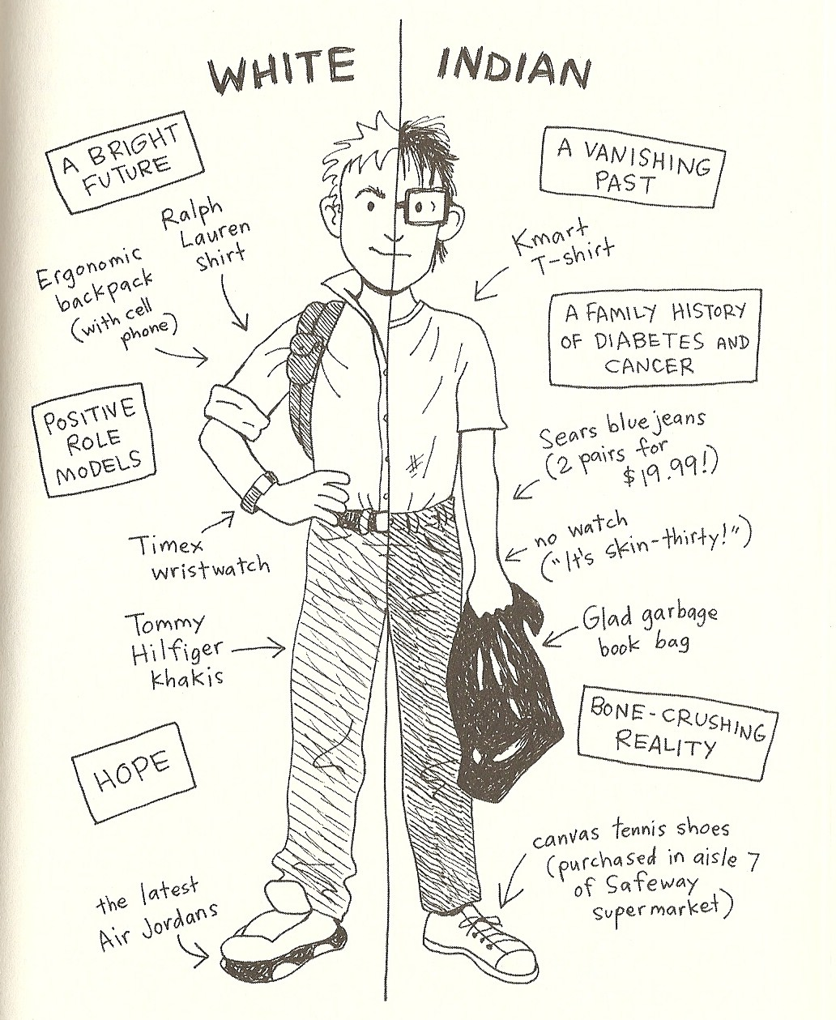
How do YOU straddle two worlds?

On a separate sheet of paper, draw your own two-sided drawing in which you describe how you sometimes feel like you are straddling two worlds.

